CS-001 Part, Mold & Material Labeling
Doc ID | CS-001
Title | Part, Mold & Material Labeling
Revision | G
Status | Draft, pending Lead signature
Effective date | 2026-10-10
Supersedes | Unlabeled everything

Approvals
Role | Name | Date
Author | Simon Starbuck (drafted with Claude, SN6 Resources) | 2026-07-12
Reviewer | simon (reviewer agent) | 2026-10-10
Approver (Composites Lead)

Revision history
Rev | Date | Author | Description of change
A | 2026-07-12 | Claude | Initial outline
B | 2026-07-28 | Claude | Language pass: fewer em dashes for rhythm variety, no content change.
C | 2026-08-03 | Claude | Out of outline. §7 written in full: the two keep-out rules, where each class of object gets its label, the three mold identification layers, pair-print relocation for parts, and the label content per class. §5 no longer claims nothing needs ordering approval, because a label printer does (CS-012). §4 defines the ID and the QR. §8 gains checks that can actually be walked.
D | 2026-08-26 | Claude | Added the R&D mark (CS-013 §4). §4 defines it and states outright that it is not a class word — the class-word list is unchanged and still maps one-to-one onto ID prefixes, so R&D PART is not a thing and TEST PANEL keeps its single meaning. §7.6 places the mark on the ID line, gives the two reasons it goes there rather than on a content line, and says what it does and does not mean. The §4 QR note records why R&D never enters the ID or the URL. §8 gains a stock-walk check.
E | 2026-08-28 | Claude | Engineering pass (CS-000 Rev C conventions). Two drawn figures: the label anatomy (Figure 1) and the mold's three identification layers with both keep-out zones dimensioned (Figure 2). No rule changed.
F | 2026-08-29 | Claude | Coupons caught up with the app's v4.0.0 R&D bench (CS-013 Rev F). STUDY and COUPON join the class words. A coupon is CPN-SNx-###, eleven characters, so its label carries a QR like everything else; the old text-only rule was a fact about the retired 15-character PNL-…-Cnn spelling. The physical rule is unchanged: nothing adhesive on the specimen, marker on the tab, printed label on the bag or tag.
G | 2026-10-10 | Claude (doc overhaul, requested by Simon Starbuck) | Caught up with what the app prints and scans. The class word is no longer printed (the name leads, as the app has done since 2026-08-13); WORK ORDER and CONSUMABLE join the list, and issues, purchases, documents and stack plans never get a label. The roll printer is a Brother QL with DK-2210 and DK-1201 rolls, not TZe tape, with roll steps in §7.1 and a 101.6 mm check in §8. New shalls: thermal roll stock never goes on anything that sees IPA, acetone or resin; a container with a UC EH&S tag gets no FEB label; Custom label is never used for a record. New §7.11 (EH&S tag), §7.12 (scanning) and §7.13 (Custom label). Storage, board, consumable and offcut rows match the printed labels; §7.1 names the real buttons; two cross-references fixed; §1's revision narrative removed (row C already records it); four §8 checks; §9 lists the public page and the EH&S join key. §7.4 step 1 adds the mold ID to the glue-up marking, in step with CS-003 §7.3 (R-003-25, Simon, 2026-10-10). Blanks are marked with the mold ID or plan name and the layer tag at tooling cut (§7.4 lead-in and §7.2, R-001-17, Simon, 2026-10-10); R-001-19 dropped (Simon, 2026-10-10). The mold label's keep-out is one rule, the 40 mm of §6 rule 2 (the Round 3 register row R-001-30); the shelf footer reads CONTENTS LISTED IN THE APP (R-OTH-25); the tacky-tape width is cited to the AT-200Y TDS (R12). Register R-001-01..30 and the Round 3 R-001-30.

1. Purpose
Unlabeled molds sat blocking shared storage for weeks while nobody was sure whose they were (PP-10), and unlabeled offcuts made "wait, which gsm is this?" a weekly guessing game (PP-09). So: everything physical gets a label that points back to a record.
This standard says what goes on each label, which stock survives where it is going, where it may and may not be stuck, and how the app prints and scans it.

2. Scope
Molds, parts (from demold onward), work orders, tooling-board stock, cloth rolls and offcuts, resin, hardener and chemical consumable containers (identified by their UC EH&S tag, §7.11), other consumables (by box or bin), mixed-chemical containers, test panels, R&D studies and coupons, jigs and fixtures, and storage locations.
Not covered: electrical and wiring labeling, which is electrical's own standard, and anything not physically ours. Records that are not physical objects never get a label: issues (PROJ), purchases (BUY), documents (DOC) and stack plans (STK). Keeping PROJ off labels is also what stops it being misread as P (app labels.js, LABELABLE).

3. References
Ref | Document | Where
R1 | PP-09, PP-10 | FEB-COMP-PP-001
R2 | CS-013 (the record a label points to, and the ID grammar) | this series
R3 | CS-011 (home locations, the storage map) | this series
R4 | CS-003 §7.3 (glue-up), CS-005 (machining), CS-004 §7 (sealing and release) | this series
R5 | CS-009 (trim, sand, bond, clear coat) | this series
R6 | CS-012 (the label printer is a purchase) | this series
R7 | CS-004 §5 and §7.1: "Never acetone, never fibrous shop towels"; IPA ≥90% wipe at every stage | CS-004
R8 | ISO/IEC 18004 (QR symbology: alphanumeric mode, 4-module quiet zone) | published standard
R9 | ASTM D3039 (tensile coupon geometry: gauge and grip sections) | published standard
R10 | CS-014 (receiving, lots and the EH&S tag; the RSS import and the EH&S reconciliation export) | this series
R11 | App code: app/labels.js (label layout, QR budget, label media, Custom label), app/scan.js (scan resolution), app/q.html (public scan page), app/core.js (EH&S tag grammar), app/README.md Labels section (roll stock limits) | 06 Composites App/
R12 | Airtech AT-200Y sealant tape TDS (the team's tacky tape) | 03 Datasheets/AIRTECH-TDS-AT-200Y-Sealant-Tape.pdf

4. Definitions
- ID: the record's own identifier, PREFIX-SNx-###, assigned by the app and never reused (CS-013 §4). The ID is the label text; there is no separate part number.
- Label: a printed 4 × 1 in label (1⅓ × 4 in on Avery 5522, 29 × 90 mm on DK-1201 die-cut). Top to bottom: the name, in the largest size that fits on one or two lines; the ID, with the R&D box when it applies; the key line in bold, which is the one fact that identifies that class of object (§7.6); a detail line; and a footer ending in the FEB mark. When the name needs two lines, the detail line folds into the footer. The QR code sits on the right (R11, labelMarkup).
- Class word: the word for what kind of object a record is: PART, MOLD, WORK ORDER, TEST PANEL, STUDY, COUPON, FABRIC, RESIN (which covers hardener; the key line says which), CONSUMABLE, BOARD, JIG, STORAGE. The app derives it from the ID prefix and shows it on the public scan page and in the app. It is not printed on the label, except on a storage location, whose key line reads STORAGE (R11, labelLines). Every other label leads with the name, because the label's vertical space is spent (R11). The list maps one-to-one onto ID prefixes. Records that are not physical objects have no class word and never get a label (§2), so PROJ-SN6-007 never sits on a shelf where it could be read as P-SN6-007.
- QR code: encodes HTTPS://FEB-COMPOSITES.WEB.APP/Q/<ID>. Uppercase, no query string, no fragment. Scanning it with any phone camera opens a public page naming the object, with no account needed. On a weak connection the page still shows the class and ID, because those come from the code itself; with no connection at all the phone cannot open the page, so read the label. This is also why the R&D mark below is printed beside the code and never encoded into it: a suffix costs a character budget and an error-correction level, a query string leaves alphanumeric mode entirely, and either would make reclassifying a build a relabelling job. The mark is on the card and mirrored to the scan page; the code itself never changes.
- Mark: a hand-written identifier in oil-based paint marker, used where a label cannot go (§7.4, §7.7).
- R&D mark: the word R&D, in a ruled box on the ID line of the label, for an object built under an R&D work order (CS-013 §4). It is not a class word and must never join the list above: the class-word list maps one-to-one onto ID prefixes and must never change under the reader, whereas R&D qualifies a class. There is no such thing as an R&D PART class: there is a PART that is marked R&D. On the printed traveler the same fact reads in full: R&D — NOT A SEASON DELIVERABLE.
- Engraving: the ID cut into a mold during machining. The record of record (§7.4).
- EH&S tag: the UC EH&S barcode sticker that campus (RSS Chemicals) puts on every chemical container at RFS and on some storage sublocations. A Data Matrix square marked RSS, with a 24-character code of uppercase letters and digits printed underneath in six groups of four, and the last twelve characters reprinted, rotated, down the right edge (the edge print). Example, made up: CA00 0000 0000 0000 0024 3F1C, edge print 0000 0024 3F1C. The app stores it in the record's EH&S barcode field as a second identity for the container (R11, core.js EHS_LEN, EHS_TAIL). FEB never prints one.
- Data Matrix: the square 2-D code on an EH&S tag. FEB's own labels are QR. The app's scanner reads both.
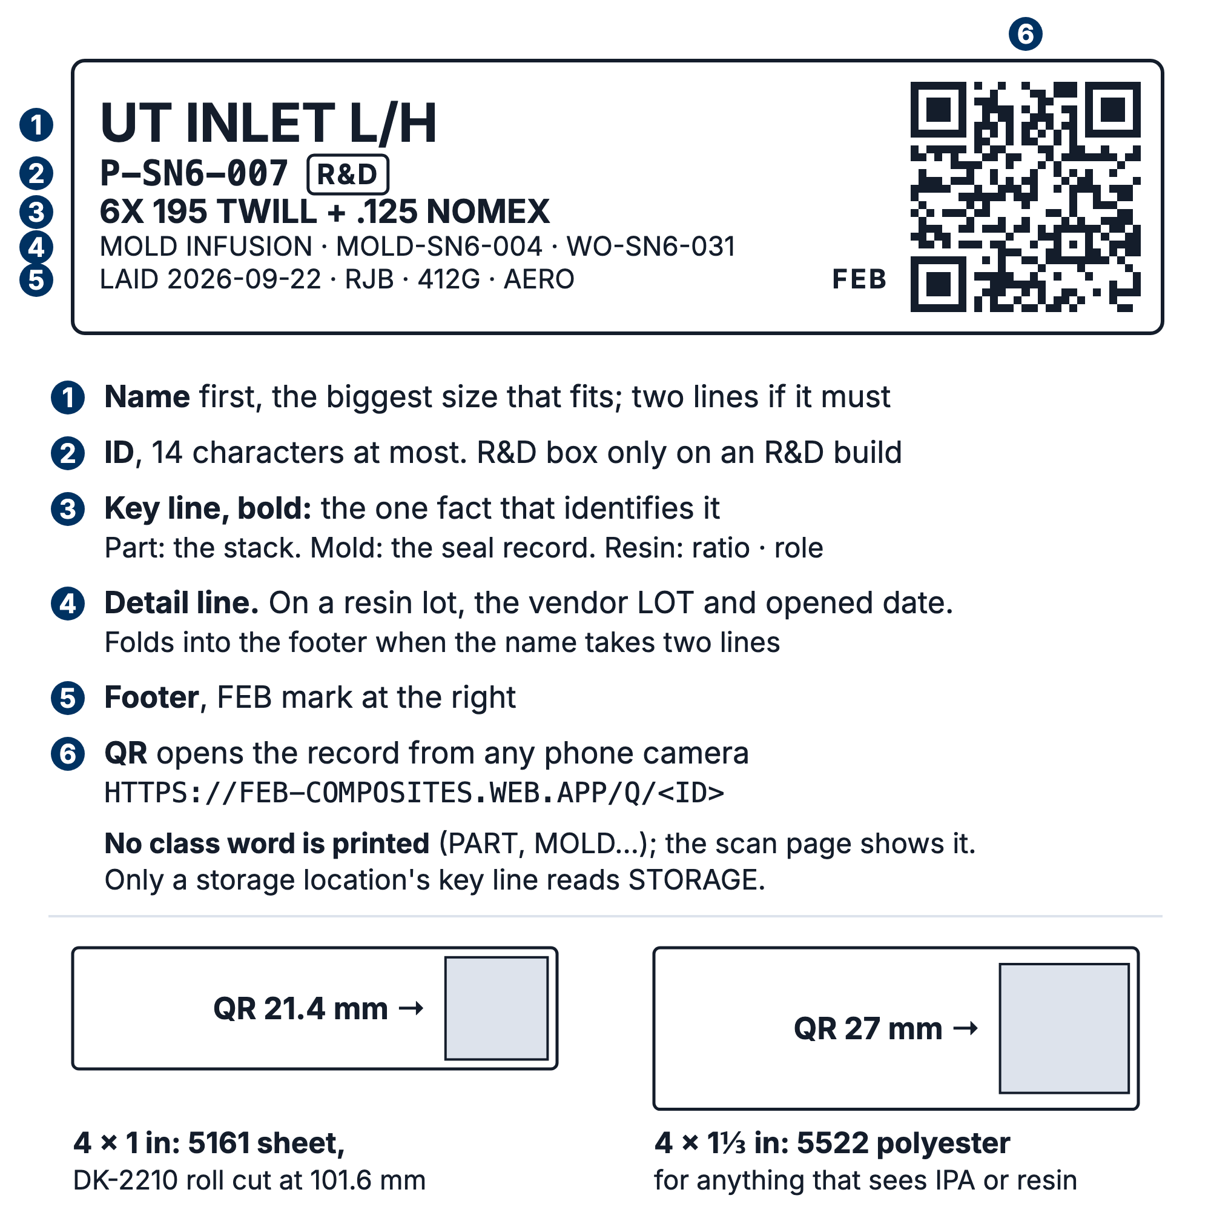
Figure 1. Label anatomy: name, ID line with the R&D box, key line, detail line and footer, beside the QR code. No class word is printed. The ID line is the only capped line, which is why the R&D mark lives there.

⚠ CAUTION: The QR payload must stay inside QR alphanumeric mode (0-9 A-Z space $%*+-./:, per R8). One lowercase letter, one ?utm=, or a # fragment pushes the code from version 3 to version 4 and drops its error correction from 25% to 15%, at the same physical size. The printed label looks identical and simply scans worse once it has resin on it. The app draws the code at 21.4 mm (27 mm on 5522) and refuses to draw one below 14 mm, with the 4-module quiet zone inside the label (R11, QR_MIN_MM, LABEL_ROLLS); do not trim a label into that margin.

5. Equipment & Materials
Item | Spec / product | Source | Notes
Paint marker | Oil-based paint marker, fine, white or silver | Campus store, ~$5 | Replaces the Sharpie for every hand mark. A standard Sharpie is IPA-soluble, and the process wipes with ≥90% IPA at every stage (R7).
Label stock, everyday | Avery 5161, 1 × 4 in, 20 per sheet | Any office supplier | Prints on the existing B&W laser.
Label stock, chemicals and solvent | Avery 5522 WeatherProof polyester, 1⅓ × 4 in, 14 per sheet | Any office supplier | For untagged chemical containers and anything else that will see IPA, acetone or resin (§7.2 stock rule). Survives a hardener drip; paper does not. The extra third of an inch lets the app draw the QR at 27 mm instead of 21.4 mm (R11).
Overlaminate | 3 in clear packing tape | Already in the shop | §7.8. Must be wider than the label.
Label printer | Brother QL-series label printer on the shed wifi, printed to over AirPrint from the phone's own print dialog | Not bought as of 2026-10-10; the request is CS-012 §7.8 | Needs ordering approval under CS-012. Not required to start: §7.8 is the documented zero-cost path and stays the fallback. The app has no printer address to set: if the printer does not appear in the print dialog, it is off the network (Reports → Label media).
Roll stock, everyday | Brother DK-2210, 29 mm continuous direct-thermal paper, cut at 101.6 mm | With the printer (CS-012) | The Avery 5161 cell to within a millimetre, so the same label on different paper (R11, LABEL_ROLLS). Direct thermal fades in UV, blackens with heat and smears under solvent (R11, app README Labels), so it is for shelves, bins, dry fabric and consumables only.
Roll stock, fallback | Brother DK-1201, 29 × 90 mm die-cut direct-thermal | With the printer (CS-012) | Only if iOS refuses a custom length on continuous stock. 86.6 mm of printable length against 101.6 mm, so long names drop to two lines sooner (R11). Same thermal limits as DK-2210.
Tags | Laminating pouches and 100 mm zip ties | Campus store | For anything tag-able: rolls, remnants, bins, coupon sets.

The label printer and its rolls go through CS-012 like any other purchase. Nothing else on this list needs ordering approval.

6. Safety
Labeling has no physical hazards of its own. Three rules exist to stop labeling from creating hazards or scrap:
- Never label a mold's working surface. Anything on the tool face telegraphs through into the part; a 0.08 mm label edge prints through two plies.
- Never label within 40 mm of a flange perimeter, on either face. Tacky tape is 12.7 mm (1/2 in) wide (R12), and a label edge under or across the seal is a leak channel you will not find at 27 inHg. CS-006 §7.4 step 3 already names tacky-tape seams as the first place to hunt leaks; do not add a second cause.
- No silicone-adhesive tape anywhere in the shop, which is Kapton and most amber films. Trace silicone causes fisheyes in clear coat and kills DP420 adhesion. Its heat resistance buys nothing here: there is no oven and no post-cure (CS-008 §5.1).

7. Procedure

7.1 Printing a label
- Open the record and press Label: on a work order, part, mold, board, test panel, jig, storage location or material lot. On an R&D study press Study label; on a coupon, press the print icon on its row. For several at once, press Labels on Inventory (and on its Items list and Materials list) or on Molds, or Label sheet under Reports → Labels. Labels and Label sheet open the Print labels builder.
- Choose the stock. The Label button prints on this device's media, set under Reports → Label media ("This device prints to"). A lead's Team default only seeds a device nobody has set. To print one record on a different stock, such as 5522 from a device set to the roll, open the builder and pick it under Media. Avery 5161 is the everyday sheet; 5522 is for anything that will see IPA, acetone or resin (§7.2 stock rule).
- On a sheet, in the Print labels builder (a record's own Label button always starts at cell 1): if the sheet has already been partly used, set Start at cell to the first unused one. A three-label batch onto a fresh sheet wastes seventeen.
- On a sheet: leave Include the 100 mm calibration bar ticked in the builder (a record's own Label button always prints it). Print, then measure the bar with a steel rule: it must be exactly 100 mm. If it is not, the browser applied "Fit to page" scaling and every label on the sheet is misregistered. Set printer scaling to 100% or Actual Size and reprint.
- Peel and apply per §7.2.
- On a roll (DK-2210 or DK-1201): there is no Start at cell and no calibration bar. For more than one of each, use the builder and set Copies of each (1 to 50, R11 LABEL_COPIES_MAX).
- On a roll: in the preview press Print, and choose the Brother QL in the phone's print dialog.
- On a roll: measure the first label of the session with a steel rule. On DK-2210 it must be 101.6 mm (R11, LABEL_ROLLS). Short or long means the print dialog scaled it; set scaling to 100% and reprint. Then apply per §7.2.
⚠ CAUTION: Browsers apply that scaling silently. Ten seconds with a rule is cheaper than a wasted sheet of polyester.

7.2 Where each class of object gets its label
Object | Where it goes | Media
Mold | Back face, inboard of the 40 mm keep-out at every edge (§6 rule 2). Never the working surface, never the flange. | Engraved plus a printed 5522 label (§7.4)
Part, at demold | Trim area, bag side, inside the CAD trim line | Printed, permanent adhesive
Part, after trim | A hidden face, ≥25 mm from any DP420 bond line, never a face that gets bagged for a secondary bond | 5522, applied before clear coat (§7.5)
Test panel | Bag side, in the offcut margin, plus coupon IDs marked across the cut lines before sawing (§7.6) | Printed plus paint marker
Tensile coupon | Paint marker on the tab only, outside the gauge section. Nothing adhesive on the specimen; the printed CPN label goes on the coupon's bag or pouch tag. | Marker plus a printed label on the bag/tag
R&D study | The bag, tray or box the study's coupons live in | Printed
Fabric roll | A tag through the core, on wire or a zip tie | Printed label on the tag
Fabric offcut bag | On the bag. Write the remaining length on the bag beside the label in paint marker, and update the record's quantity. | Printed plus paint marker
Resin, hardener or chemical consumable wearing a UC EH&S tag | No FEB label. The EH&S tag is its label; record it in the lot's EH&S barcode field (§7.11). | Campus tag
Resin, hardener or chemical consumable with no EH&S tag yet | On the container. When campus tags it, record the tag and leave the FEB label on (§7.11). | 5522 only
Consumable (cups, bag film, tape) | On the box or bin holding them, one label per record. A chemical consumable (release agent, acetone) follows the two rows above. | Printed
Mixed pot | Write-on tape and marker (§7.7). Nothing printed, ever. | Tape
Tooling board sheet | Direct paint marker on the face, 15 mm characters | Marker
Tooling board blank, cut and not yet glued | Paint marker: the mold ID (or the plan name) and the layer tag from the cut sheet, written before it leaves the saw (§7.4) | Marker
Board remnant | The ID in paint marker on the face, plus the printed board label on a taped tag (it carries density, dimensions and the mold it came off). Print it from Print labels on the bar that appears after Mark cut. | Marker plus printed tag
Storage location | Front edge of the shelf, readable standing up (§7.10) | Printed
Jig, fixture | A non-clamping face | Printed; stamped aluminium if it outlives the season

Stock rule. Anything that will see IPA, acetone or resin shall get a 5522 polyester label, or a §7.8 overlaminated sheet label where 5522 is not on hand, never direct-thermal roll stock (DK-2210, DK-1201). Thermal paper fades in UV, blackens with heat and smears under solvent (R11, app README Labels). Roll stock is for shelves, bins, dry fabric and consumables.
⚠ CAUTION: A coupon label in the gauge section changes the cross-section and can seed the failure; in the grip section it changes thickness and causes slip (R9). Marker on the tab is the only correct answer.

7.3 Engrave, encapsulate or laminate: choosing the label method
The durable answer for a tool is subtractive: engrave it. For a part it is encapsulation: put the label under the clear coat. For everything else it is laminated or polyester media, with thermal roll stock only for dry indoor things (§7.2 stock rule). Choose in that order.

7.4 A mold is identified three times
There is no moment when a flange label is clean: XCR goes over the whole working surface and the flanges, then four coats of wax, then PVA. So a mold gets three artifacts with three lifetimes. Before any of them, each blank is marked as it comes off the saw (CS-003 §7.3 step 4): its mold ID (or the plan name) and its layer tag from the cut sheet (L1, L2b), in paint marker, so the loose blanks for several molds cannot be mixed up before glue-up. Step 1 then marks the glued stack.
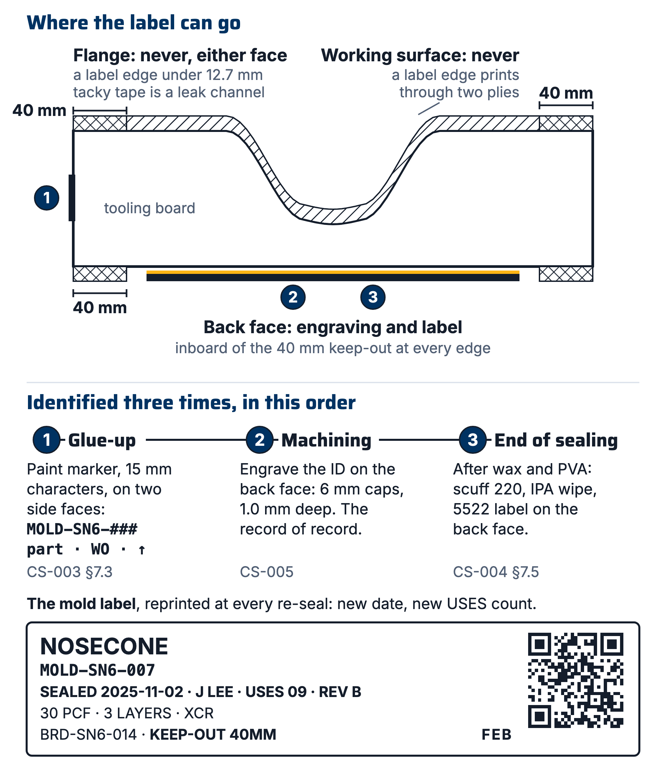
Figure 2. Where a mold's identity lives, and the two keep-out zones: never the working surface, never within 40 mm of the flange perimeter on either face.

- At glue-up (CS-003 §7.3). Mark the mold ID (MOLD-SN6-###), the part name, the WO and an up arrow in paint marker, 15 mm characters, on two adjacent side faces of the glued stack. Between glue-up and the CNC slot a glued block sits on a shelf beside three other glued blocks, which is the highest-confusion and lowest-cost-to-fix moment in the whole process. Mark faces the toolpath will remove less than 6 mm from, or mark the bottom.
- At machining (CS-005). Engrave the mold ID on the back face: 6 mm cap height, 1.0 mm deep, single-line font, 3.175 mm ball or 90° V-bit. The machine is already set up and the part already fixtured, so it costs about 90 seconds. This is the record of record. It survives IPA, acetone, four coats of wax, PVA, sanding, the label falling off, and the printer being broken. Every other layer is a convenience wrapped around it.
- At the end of sealing (CS-004 §7.5 Identify). After the fourth wax coat is buffed and the PVA is dry, so every wet operation is finished. Scuff a patch of the back face to 220 grit, wipe with IPA, apply the printed 5522 label. Tooling board is porous; without the scuff the adhesive has nothing to key into and the label curls off within a month.
⚠ CAUTION: Do not apply the printed label before sealing. It either gets brushed over with XCR, becoming a permanent bump in the seal coat, or it gets peeled off and leaves adhesive that XCR will not wet out.
Re-sealing. When a mold is stripped and re-sealed, the old label comes off with the strip and a new one is printed, carrying the incremented parts-pulled count and the new seal date. That is a feature: a label reading SEALED 2025-11-02 · J LEE · USES 09 is telling you something important, and forcing the reprint is how it stays true.

7.5 A part's label moves once, by printing two
Do not peel and re-stick. A label peeled off a demolded part carries wax and PVA on its adhesive. It will not restick to a freshly sanded face, and if it does, it puts release agent onto a surface about to be clear-coated.
- At demold (CS-006 / CS-007). Print two identical labels on 5522 (use the Print labels builder and §7.1 step 3 for a second print on the same sheet). Apply label A to the trim area on the bag side, inside the CAD trim line. Staple label B to the work order traveler.
- At trim (CS-009). Label A is cut off and discarded with the trim. Identity now lives on the traveler, which is physically with the part.
- After sanding, before clear coat (CS-009). Apply label B to the scuffed, IPA-wiped hidden face.
- Clear coat (CS-009). The acrylic urethane goes over label B where geometry allows, encapsulating it permanently.
The pair is 5522 because label B goes under clear coat (§7.2 stock rule). On a sheet the app prints one label per record, so the second label is a second print. On a roll, Copies of each set to 2 prints the pair, but roll stock is thermal paper, so a roll pair serves only a part that will not be wiped or clear-coated.

7.6 What the label says
Every label carries the name and the ID. The bold key line under those is the one fact that identifies that class of object, and it is the reason the label is worth printing:
Class | The identifying fact
Part, test panel | The layup stack, in CS-002 shorthand (6X 195 TWILL + .125 NOMEX)
Mold | The sealing record: sealed date, by whom, parts pulled, revision
Fabric | No key line (dry fabric has no ratio or role); the vendor lot number is on the detail line under the ID; received date and shelf in the footer. Dry fabric has no expiry field (R11, shop.js).
Resin, hardener, consumable with no EH&S tag | The vendor lot number and opened date, on the line under the bold mix ratio and role; received date, expiry and shelf in the footer. A container wearing an EH&S tag gets no FEB label (§7.2).
Board, remnant | Density in the key line; dimensions and quantity beneath; the mold it came off and its shelf in the footer
Storage location | Key line STORAGE; site and kind of location, and FLAMMABLES OK when the shelf is rated for flammables. The footer reads CONTENTS CONFIRMED <date> after a walk (§7.10), or CONTENTS LISTED IN THE APP before the first one; the contents show when scanned in the app, not on the public page.

"What layup stack was used for seat last year" is the question PP-09 records nobody being able to answer. It is on the label, so it can be answered with the phone still in your pocket.
The vendor lot and expiry print from whatever the record holds. If they were filled by ✨ Read label on the lot's page, check them against the container before printing. CS-014 owns that rule for every AI fill.
R&D builds. A part, panel or mold produced under an R&D work order (CS-013 §4) carries the mark R&D in a ruled box on the ID line, to the right of the ID. It sits there rather than on any content line for two reasons. The ID is the only line on the label whose length is capped (14 characters, CS-013 §4.1), so it is the one place a mark can be put and guaranteed never to truncate; the name, the key line and the footer cut long content short, and the detail line folds into the footer whenever the name needs two lines. And R&D qualifies the object's identity, not the fact printed beneath it. The mark never displaces the identifying fact above, and never displaces the FEB mark.
The mark says the part is not a season deliverable. It does not say the part is scrap, a mock-up, a draft, or exempt from this standard. An R&D part is real carbon with a real cost, and it gets the same label, the same record and the same traceability as anything else on the shelf.
Coupons. Write every coupon ID on the panel before the first cut, across the cut lines, so each piece inherits a legible fragment. A coupon is CPN-SNx-###, its own record on the app's R&D bench under a study RDS-SNx-### (CS-013 §4.1). At eleven characters both fit the QR budget, so their printed labels carry a QR like everything else; the label goes on the coupon's bag or tag and the study's on the tray, never on the specimen (§7.2). The retired PNL-SNx-###-Cnn spelling was 15 characters, over budget, which is why SN5-era coupon labels are text-only.

7.7 Mixed pots and opened containers
A pot of XCR has an 8 minute pot life at 20 °C (CS-004 §7.3). Printing a label for it is a process smell: it means someone stood at a printer while pot life burned. Write on the cup:
`
IN2 2142 JS product · time mixed (HHMM, 24 h) · initials
XCR 0906 SS 140g add batch mass where CS-004 §7.3 requires it
`
Four characters of time is what a gloved hand will actually write on a curved cup, and the minute is the only granularity that answers what a pot label is asked: is this still good, and whose is it. Anything unlabeled and curing is treated as hot waste (CS-008).
Anything opened but not given a lot record gets an opened sticker: OPEN 2026-10-14 JS.

7.8 When there is no label printer
This is the documented path, not a degraded one, and it stays the fallback after a printer is bought.
- Print the label sheet on plain paper from the app.
- Cut on the guillotine, on the crop marks. Not with scissors.
- Overlaminate with 3 in clear packing tape, overlapping the label by at least 6 mm on all four sides, so the paper is fully encapsulated with no exposed edge anywhere. Burnish hard with a thumbnail.
⚠ CAUTION: Done this way it survives repeated IPA wipes, CF dust and compressed air for months, because the solvent never reaches paper or toner. Done wrong, with the tape flush to the label edge, solvent wicks underneath and it delaminates in a week. 2 in tape over a 2 in label is exactly wrong.
For anything tag-able, a laminating pouch on a zip tie beats packing tape, because the lamination seals all four edges. Punch the hole through the sealed margin, never through the paper.

7.9 When the printer breaks the week before comp
In order:
- The spare roll, taped to the printer in a bag, permanently, never allowed to become the working roll. Most of "the label printer is broken" is an empty or jammed roll, or a printer that has dropped off the shed wifi and so does not appear in the print dialog.
- Avery 5161 on the office laser through the app (pick 5161 under Media in the builder if the device is set to the roll), with the §7.8 overlaminate. Full fidelity, one grade down in durability, and no purchase decision at 11 pm. Keep one unopened box in the cabinet.
- Paint marker on masking tape. Always works, never scannable, acceptable for 72 hours.

7.10 Labeling a shelf or storage location
Every shelf, bin and rack holding tracked composites material gets a storage record and a label on its front edge, printed from that record and not from Custom label (§7.13). That is what turns the location field into a controlled value rather than the freeform string CS-011 §7.3 flags, and it is what lets a move be recorded by scanning the object and then the shelf (§7.12).
- On Inventory → Storage map, press + Location and fill in Name, Site, Type and Rated for flammables.
- On the location's page, press Label. Fix it to the front edge of the shelf, readable standing up.
- If campus has put an RSS tag on the shelf or cabinet, press Edit location and enter that tag in EH&S barcode (or use the scan button beside it, Scan the EH&S tag), so either tag finds the shelf.
- After a stock walk, press Confirm contents on the shelf's page. The confirmed date prints in the label's footer (§7.6), so it is only as current as the last reprint.

7.11 Chemical containers and the UC EH&S tag
Campus EH&S (RSS Chemicals) puts a tag on every chemical container at RFS. That tag is the container's label, and FEB does not add a second sticker to a tagged container (§7.2). The app stores the tag on the lot record, in EH&S barcode, so scanning the campus tag opens the FEB record. Resin, hardener and consumable lots and storage locations carry that field; fabric lots do not, because dry fabric is not in the campus chemical system (R11). The receiving desk itself, the RSS import and the reconciliation export are CS-014.
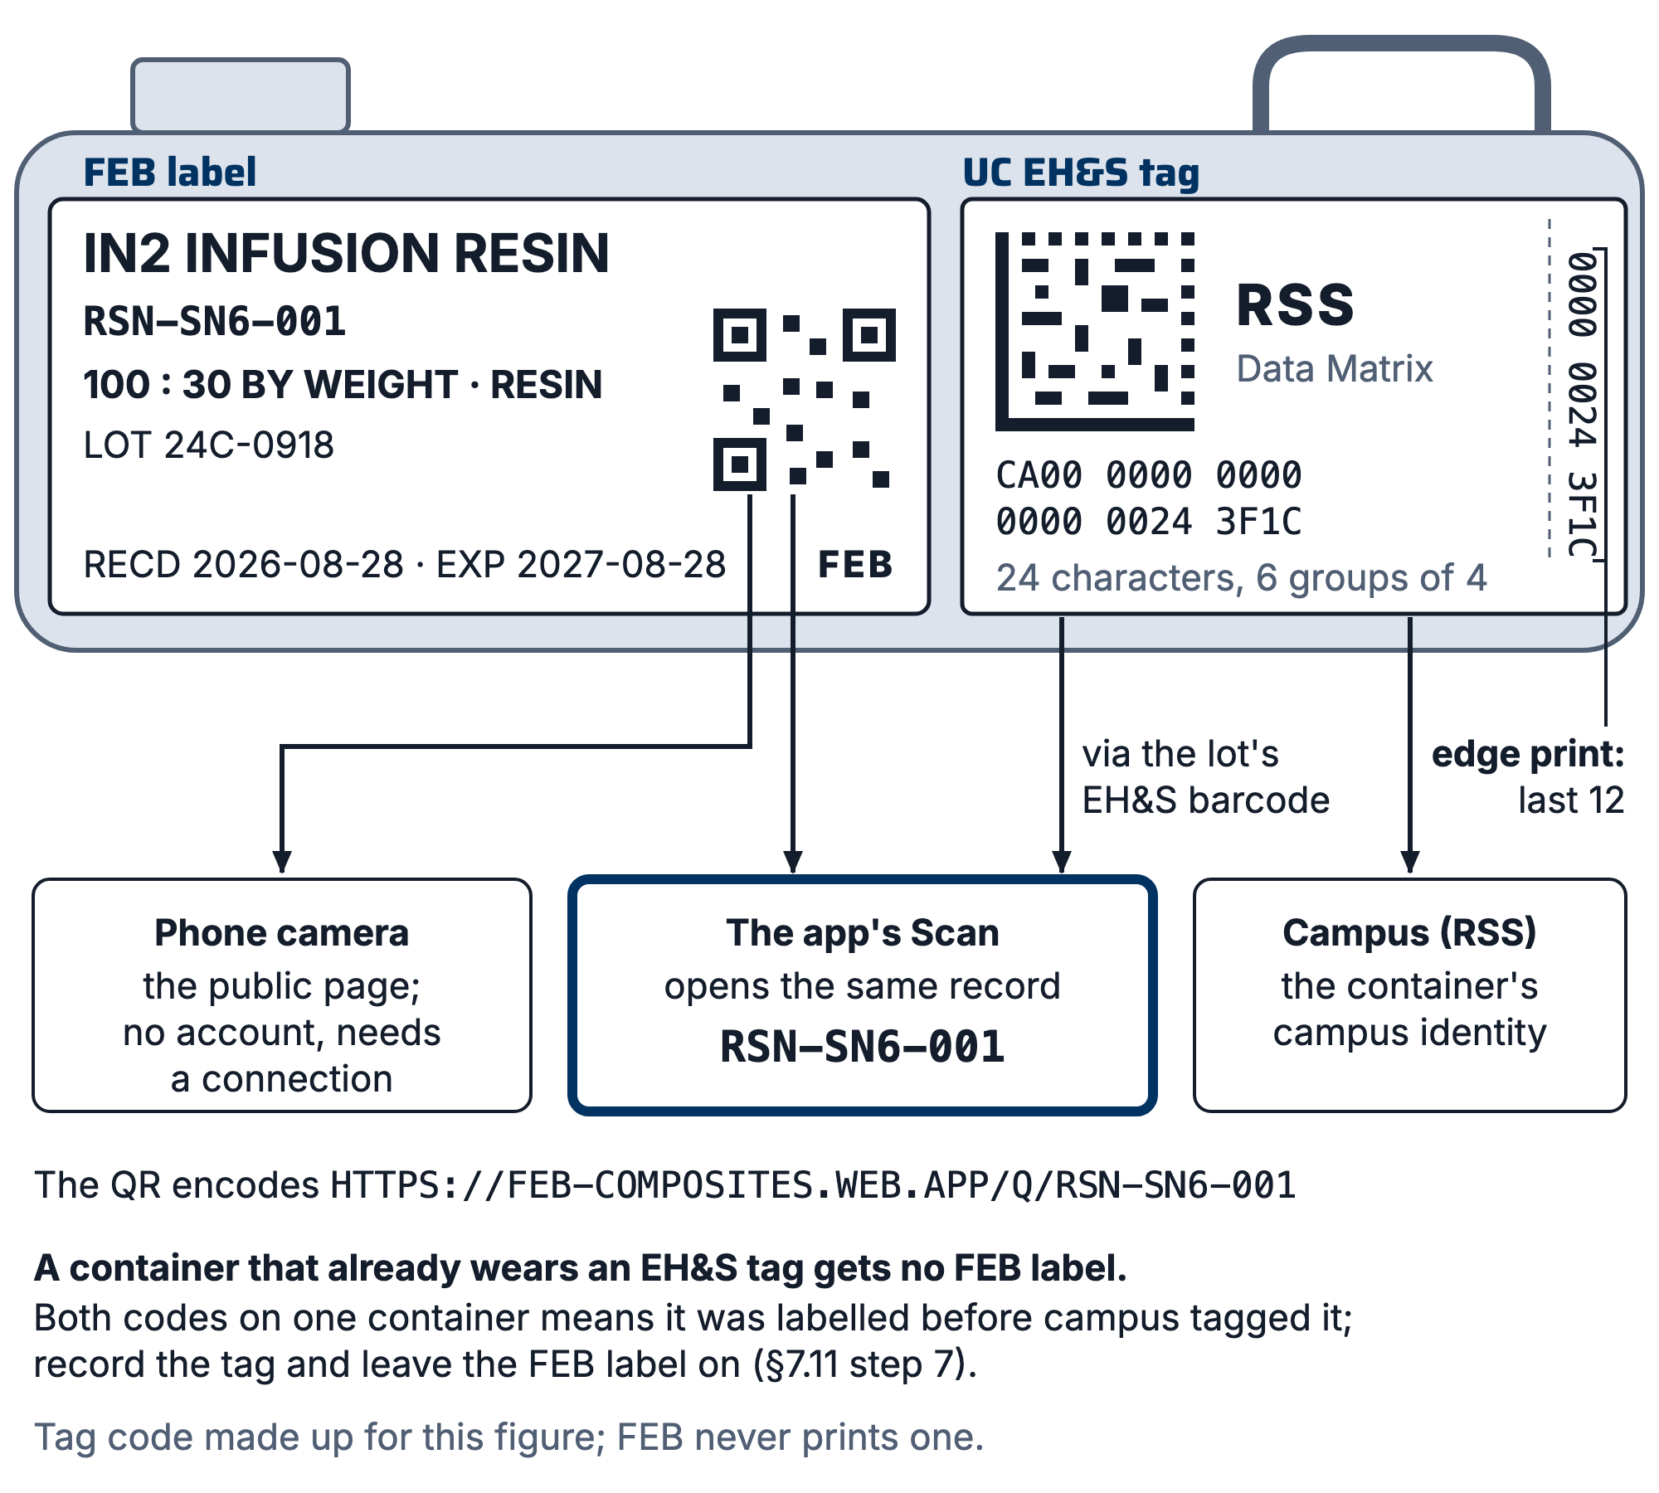
Figure 3. Two codes on one container: the FEB QR label and the UC EH&S Data Matrix tag, and what each one opens when scanned.

- At receiving, press Receive a delivery on Inventory to open the Receiving desk. Scan or type each container's tag into the EH&S tag cell of its line. The scan button beside the cell (Scan the tag(s) with the camera) stays open across codes. A line for several containers takes several codes, separated by spaces or commas, dealt to the records in order.
- For a container already on a shelf: open its record, press Edit, and press the scan button beside EH&S barcode (Scan the EH&S tag), or type the code.
- If the face of the tag is scuffed or wrapped round a bottle neck, type the twelve characters printed down its right edge. Twelve is the fewest the app matches as part of a code; if two containers share those twelve, it refuses and asks for more of the code (R11, core.js EHS_TAIL).
- One tag, one container. The app refuses a tag that another record already wears and names that record. Fix whichever record is wrong; never put one code on two records.
- A tag no record wears, scanned with the app's Scan, offers Log it, which opens the Receiving desk with the code already in the tag cell. Log the container there (CS-014).
- A code that is not 24 characters saves with a warning, because older hand-entered codes are shorter and real. Check it against the tag before moving on.
- A chemical container with no tag yet gets a 5522 FEB label (§7.2). When campus tags it, enter the tag in EH&S barcode and leave the FEB label on: a label is never peeled off (§7.5).

7.12 Scanning a label
There are two ways to scan, and they open different things. A phone's own camera pointed at an FEB QR opens the public page for that record (§9): no account, but it needs a connection. Inside the app, the scan button in the top bar (Scan a label) opens Scan, which reads an FEB QR or a UC EH&S tag and opens the record itself. On an iPhone the app loads its scanner the first time, which takes a few seconds.
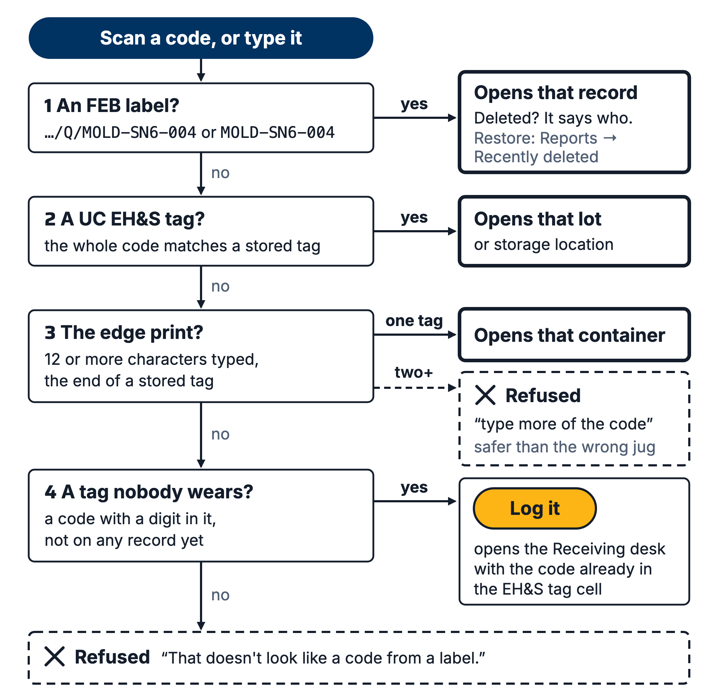
Figure 4. How the app resolves a scanned code: an FEB /Q/ link opens the record it names; otherwise an exact EH&S tag; otherwise a 12-character edge print (refused if it matches two containers); an unknown tag offers "Log it" at the Receiving desk.

- To open a record, press the top-bar scan button and point the camera at the label.
- To move one thing, open it (a mold, item or lot), press Move, then Scan the shelf and point the camera at the shelf's label. Picking the shelf under Location and pressing Move it does the same without the camera.
- To restock a shelf, open the shelf's page from Inventory → Storage map, press Move here (scan), and scan each thing as you put it on the shelf. The camera stays open and each scan saves as it lands; press Cancel to close the camera when the pile is done.
- Either code works at either end: the FEB QR or the UC EH&S tag on a container, and the shelf's FEB label or its RSS tag once that is recorded (§7.10 step 3).
- If the camera will not open or will not read the code, type it into "…or type the code" and press Use this code: the ID (MOLD-SN6-004), or a tag's last twelve characters. The app accepts the full URL, the bare ID, lowercase, or spaces.

7.13 Labels with no record (Custom label)
Custom label prints typed text with no record behind it: a cabinet sign, a warning such as DO NOT CUT, a bin of untracked things. It is on the Inventory toolbar, on a storage location's page, and under Reports → Labels. Its fields are Name (the big line), Second line, Key line (bold), Footer, QR (optional), Media, and Copies (roll media only); Print one again lists the last ten printed on this device.
- Custom label shall not be used for anything that has a record. Open the record and press its own Label, which prints the identifying fact and a QR that resolves.
- A custom label shall not carry an ID-shaped line. The app enforces this on the Second line: a real ID is sent back to its record's Label button, and an invented one is refused outright (R11, clProblem).
- A shelf that holds tracked material gets a storage record and its own Label (§7.10), not a custom label.
- The QR text can carry only 0-9 A-Z space $%*+-./: (R8); anything else, such as ?, #, & or _, is refused (R11, clQrTrouble). Lowercase is uppercased. The app refuses a code whose modules would come out under 0.4 mm at the label's QR size; shorten the text.
- With no printer at all, paint marker on masking tape (§7.9 step 3) does the same job for 72 hours.

8. Quality checks / acceptance criteria
Check | Target | Method | Record where
Every mold in shared space carries an engraved ID | 100% | Monthly stock walk (CS-011) | Walk notes
Every mold carries a current printed label | 100% | Monthly stock walk; a label whose seal date predates the last re-seal counts as failed | Walk notes
No unlabeled cloth in the cutting area | 100% | Spot check at every layup | None
No label within 40 mm of a flange seal band | 100% | Checked at bagging, before pulling vacuum | WO step note
Sheet: calibration bar measures 100 mm | Every print session | Steel rule | None
Roll: the first label measures 101.6 mm (DK-2210) | First label of every print session | Steel rule | None
Coupon IDs written on the panel before the first cut | 100% | Checked at the saw | Panel record
Parts carry their hidden-face label before clear coat | 100% | CS-009 finishing check | WO quality checks
R&D parts carry the R&D mark on their label | 100% | Monthly stock walk (CS-011); a part built under an R&D work order whose label has no mark counts as failed | Walk notes
Hand marks use a paint marker, not a Sharpie | 100% | Spot check | None
Every chemical container on a shelf has its EH&S tag recorded, or a 5522 FEB label if it is untagged | 100% | Monthly stock walk, with Inventory → Export → EH&S reconciliation | Walk notes
No thermal roll label on anything that sees IPA, acetone or resin | 100% | Spot check | None
Every shelf holding tracked material has a storage record and its label | 100% | Monthly stock walk | Confirm contents on the shelf's page

9. Records
The labels themselves, the records they point at, and the location field on each record, which is what the monthly stock walk checks against. A scan of any label resolves to the public page for that record, so a stock walk can be done with a phone, a connection and no account. Beside those, the app keeps:
- EH&S barcode on resin, hardener and consumable lots and on storage locations. It is the join key between FEB's records and campus's RSS Chemicals inventory (Inventory → Export → EH&S reconciliation; CS-014).
- The public nameplate for every labelled record, which is what a phone-camera scan opens. It shows the class, ID and name, then Stage, Location (the shelf's name), Work order, Revision, Updated, and the R&D note on an R&D build. It never shows a layup stack, a sealing record or a person (R11, pubProjection; firestore.rules /pub). A lead rebuilds every nameplate with Rebuild scan mirror under Reports → Maintenance.
- Contents last confirmed and Confirmed by on each storage location, stamped by Confirm contents (§7.10 step 4).
A label that scans to "No record with this ID yet" on the public page was printed before its record was saved, belongs to another season, belongs to a deleted record, or is waiting on Rebuild scan mirror. Scanned inside the app, a deleted record's label says who deleted it and when. Restore it under Reports → Recently deleted, where a deleted record stays for 30 days (R11, core.js TRASH_DAYS). Do not relabel; restore.

